## Introduction

## Material and methods

### Contamination of biota by metals and organohalogen compounds

#### Data source

Concentrations of various contaminants were measured in bivalves collected from three major French estuaries (Gironde, Loire, and Seine) over the period 1979 to 2024, as part of the ROCCHMV monitoring program. In the Gironde estuary, the Pacific oysters (*Crassostrea gigas*) was monitored. In the Seine estuary, the blue mussel (*Mytilus edulis*) was studied. In the Loire estuary, the blue mussel was initially monitored, and, from 2017 onward, *oysters* were also included in parallel. Sampling was conducted in the most saline zones of each estuary, near their respective mouths (Figure 1).

|  |  |  |
| --- | --- | --- |
|  |  |  |
| Figure 1 - Map of sampling points for the ROCCHMV program. The numbers indicate the number of years these points have been monitored. | | |

#### Data transformations

When multiple measurements were available for the same year, the annual median value was used. Values under limit of detection were replaced by zero value. The similarity in bioaccumulation potential between mussels and oysters was assessed based on differences in their contamination levels. Where differences were observed, such as those documented for several metals (Ifremer, 2024), all concentrations were expressed in “mussel equivalents” using an oyster-to-mussel conversion factor. This factor was calculated for each metal as the ratio of median contamination levels in oysters to those in mussels, based on seven years (2017-2024) of parallel monitoring in the Loire estuary. The resulting conversion factors were 0.634 for mercury, 0.718 for cadmium, 0.898 for lead, and 0.036 for copper.

#### Data analysis

Recent trends were estimated using the last 15 years of time series data, applying Spearman’s rank correlation coefficient (ρ). Statistical significance of the correlations was tested using the cor.test function from the {stats} package in R. For each estuary and each compound, the correlation coefficient and its associated p-value were used to evaluate the presence and direction of recent trends.

Long-term trends were assessed using the Kruskal-Wallis rank sum test (kruskal.test, {stats} package), based on contamination data from the first and last five-year periods, for compounds with more than 20 years of monitoring data. To compare contamination levels between compounds and estuaries, median values were calculated for both periods. For compounds monitored for fewer than 20 years, long-term trends were not estimated. Instead, contamination levels were compared using median values calculated over the entire monitoring period.

#### Studied compounds

The full list of contaminants monitored under the ROCCHMV program is available on the “Envlit” website maintained by Ifremer (<https://envlit.ifremer.fr/Surveillance-du-littoral/Contaminants-chimiques/Contaminants-suivis>). For the present study, a subset of compounds was selected and is listed in Table 1, based on the following criteria: (1) compounds subject to European or national regulatory thresholds for human health and ecotoxicological risk in biota (European Commission, 2013; legifrance.gouv, 2023; OSPAR, 2023); and (2) compounds with concentrations above the detection limit in the present dataset.

Table 1 summarizes the main sources, ecotoxicological effects, and bioaccumulation potential of the selected compounds, as synthetized from (Ifremer, 2021). The table also presents the relevant legislative thresholds, specifying their regulatory context (human health or ecotoxicology), the biological matrix of reference (primarily bivalves or fish), and the legislative source.

Three legislated heavy metals have been studied (mercury, cadmium, and lead). Copper was also included due to its historical significance as a pollutant in the Gironde estuary (Ifremer, 2024). Two types of organochlorine (OC) pesticides are under legislative thresholds: γ**-HCH** (**or Lindane)** and so called DDT total (sum of isomers p,p'-DDT (4,4’-DDT), o,p’-DDT (2,4’-DDT), p,p'-DDE (4,4’-DDE), p,p'-DDD (4,4’-DDD)). Eight **Polycyclic Aromatic Hydrocarbon** (PAH) are under OSPAR legislation: fluoranthene, benzo(a)pyrene (abr. benzo-pyr.), anthracene, naphthalene, phenanthrene, pyrene, benzo(a)anthracene (abr. benzo-anthra.), and benzo(g,h,i)perylene (abr. benzo-peryl.).

Table 1 – Characteristics and thresholds in biota for the selected contaminants.  
Threshold type related to human health: QS(HH) (EU Quality Standard for Human Health), EC MPC (European Commission maximum permissible concentrations).   
Threshold types related to ecotoxicology: EQS (EU Ecological Quality Standard), EAC (Environmental Assessment Criteria: North-Est Atlantic OSPAR equivalent of EQS), BAC (Background assessment Concentration: North-Est Atlantic OSPAR for 'close to background’ in natural conditions) NQE (Norme de Qualité Environnementale: French equivalent of EQS), VGE (Valeurs Guide Environnementales: French equivalent of EQS for bivalves).   
Matrix abbreviations: f.: fish, c: crustaceans, m: molluscs, b: bivalves, g: gastropods.   
(E) concentration in Mytilus edulis in wet weight based on a 16.4% dry weight in soft body (OSPAR, 2023d)  
(G) concentration in Crassostrea gigas in wet weight based on a 18.0% dry weight in soft body (OSPAR, 2023d)  
(*) Refers to the following compounds: 7 polychlorinated dibenzo-p-dioxins (PCDDs): 2,3,7,8-T4CDD, 1,2,3,7,8-P5CDD, 1,2,3,4,7,8- H6CDD, 1,2,3,6,7,8-H6CDD, 1,2,3,7,8,9-H6CDD, 1,2,3,4,6,7,8-H7CDD, 1,2,3,4,6,7,8,9-O8CDD (OCDD); 10 polychlorinated dibenzofurans (PCDFs): 2,3,7,8-T4CDF, 1,2,3,7,8-P5CDF, 2,3,4,7,8-P5CDF , 1,2,3,4,7,8-H6CDF, 1,2,3,6,7,8-H6CDF, 1,2,3,7,8,9-H6CDF, 2,3,4,6,7,8-H6CDF, 1,2,3,4,6,7,8-H7CDF, 1,2,3,4,7,8,9-H7CDF, 1,2,3,4,6,7,8,9-O8CDF (OCDF) ; 12 dioxin-like polychlorinated biphenyls (PCB-DL): PCB 77, PCB 81, PCB 105, PCB 114, PCB 118, PCB 123, PCB 126, PCB 156, PCB 157, PCB 167, PCB 169, PCB 189.  
(§) The threshold of 0.0065 ng/g TEQ refers to the weighted sum of compounds concentrations expressed in toxic equivalents (TEQ), using a multiplication factor known as the toxic equivalency factor (TEF according to the World Health Organization 2005 for mammals). This factor reflects the toxicity of each compound relative to the reference dioxin (2,3,7,8-TCDD), which has a TEF of 1.   
¤ long term evolution, last short term evolution, deviation from limit value (blue: [0-50%[, green: [50-100%[, yellow:[100-150%[, orange: [150-300%[, red: [300-500%[, black: > 500%)

|  |  |  |  |  |  |  |  |  |  |  |  |
| --- | --- | --- | --- | --- | --- | --- | --- | --- | --- | --- | --- |
|  |  |  |  |  |  |  |  |  | EVALUATION¤ | | |
| Family | Contaminant | Main Sources | Ecotoxicological Effects | Bioacc. | Time series | Threshold | Matrix | Type (source) | Gironde | Loire | Seine |
| Historically monitored heavy metals | Mercury (Hg) | Coal combustion, mining | Neurotoxicity, reproduction impairment | Very high | 1979-2024 | 500 ng/g ww | b | EC MPC (OSPAR, 2023a) | → → 🔵 | → → 🔵 | → → 🔵 |
| Cadmium (Cd) | Mining, batteries, pigments, electroplating | Kidney damage, growth inhibition | High | 1979-2024 | 1000 ng/g ww | b | EC MPC (OSPAR, 2023a) | ↓ → 🟠 | ↓ ↓ 🔵 | ↓ → 🔵 |
| **Lead (Pb)** | Leaded fuels, paint, batteries | Neurological and developmental toxicity | High | 1979-2024 | 1500 ng/g ww | b | EC MPC (OSPAR, 2023a) | → → 🔵 | ↓ ↓ 🔵 | → → 🔵 |
| **Copper (Cu)** | Antifouling paints, mining, plumbing | Oxidative stress, enzyme disruption | Medium | 1979-2024 | - | - | - | - | - | - |
| **Organochlorin pesticides** | DDT total | Insecticide (historical), degradation product and main metabolite | Endocrine disruptor, reproductive impact, hepatic toxicity, potential carcinogen | Very high | 1979-2023 | 1282 ng/g ww | b | VGE (Légifrance, 2023 Tableau 99) | ↓ → 🔵 | ↓ → 🔵 | ↓ ↓ 🔵 |
| **Lindane** or γ**-HCH** | Insecticide (historical) | Neurotoxicity, reproduction effects | High | 1982-2023 | 0.29 ng/g ww | b | EAC (Ineris, 2022) | ↓ ↓ 🔵 | ↓ NA 🔵 | ↓ ↓ 🔵 |
| **Polycyclic aromatic hydrocarbon (PAH)** | **Fluoranthene** | Combustion, oil spills | Carcinogenicity, oxidative stress, DNA binding, nervous system effects, phototoxicity | High | 1994-2024 | 110 ng/g dw | b | EAC (OSPAR, 2023b) | → → 🔵 | ↓ → 🔵 | ↓ → 🔵 |
| **Benzo(a)pyrene** | Very high | 600 ng/g dw | b | EAC (OSPAR, 2023b) | → ↓ 🔵 | → → 🔵 | → → 🔵 |
| **Pyrene** | High | 100 ng/g dw | b | EAC (OSPAR, 2023b) | → → 🔵 | ↓ → 🔵 | ↓ → 🔵 |
| **Benzo(a)anthracene** | High | 80 ng/g dw | b | EAC (OSPAR, 2023b) | → → 🔵 | → → 🔵 | → → 🔵 |
| **Benzo(g,h,i)perylene** | High | 110 ng/g dw | b | EAC (OSPAR, 2023b) | → ↑ 🔵 | ↓ → 🔵 | → → 🔵 |
| **Anthracene** | Medium | 290 ng/g dw | b | EAC (OSPAR, 2023b) | → → 🔵 | → → 🔵 | → → 🔵 |
| **Naphtalene** | Medium | 340 ng/g dw | b | EAC (OSPAR, 2023b) | → → 🔵 | → ↓ 🔵 | ↓ ↓ 🔵 |
| **Phenanthrene** | Medium | 1 700 ng/g dw | b | EAC (OSPAR, 2023b) | → → 🔵 | ↓ → 🔵 | ↓ → 🔵 |
| **Organochlorin pesticides** | **Hexachlorocyclohexane gamma (Gamma-HCH or Lindane)** | Insecticide (historical) | Neurotoxicity, reproduction effects | High | 1982-2023 | 0.29 ng/g ww | b | EAC (Ineris, 2022) | ↓ ↓ 🔵 | ↓ NA 🔵 | ↓ ↓ 🔵 |
| DDT total: sum of isomers p,p'-DDT (4,4’-DDT), o,p’-DDT (2,4’-DDT), p,p'-DDE (4,4’-DDE), p,p'-DDD (4,4’-DDD) | Insecticide (historical), degradation product and main metabolite | Endocrine disruptor, reproductive impact, hepatic toxicity, potential carcinogen | Very high | 1979-2023 | 1282 ng/g ww | b | VGE (Légifrance, 2023 Tableau 99) | ↓ → 🔵 | ↓ → 🔵 | ↓ ↓ 🔵 |
| Polychlorinated Biphenyls indicators (PCBi) | **PCB 28** | Dielectric fluids, sealants | Endocrine disruptors, immunotoxicity, reproductive disorders, potential carcinogens | Very high | 1988-2024 | **67 ng/g lw** | b | EAC (OSPAR, 2023d) | ↓ → 🔵 | ↓ → 🔵 | ↓ → 🔵 |
| **PCB 52** | **108 ng/g lw** | ↓ → 🔵 | ↓ → 🔵 | ↓ ↓ 🟡 |
| **PCB 101** | **121 ng/g lw** | → → 🟢 | ↓ → 🔵 | ↓ → 🔴 |
| **PCB 118** | **25 ng/g lw** | → → 🟠 | ↓ → 🟠 | ↓ ↓ ⚫ |
| **PCB 138** | **317 ng/g lw** | ↓ → 🔵 | ↓ → 🔵 | ↓ → 🟠 |
| **PCB 153** | **1585 ng/g lw** | → → 🔵 | ↓ → 🔵 | ↓ → 🟢 |
| **PCB 180** | **469 ng/g lw** | ↓ → 🔵 | ↓ → 🔵 | ↓ → 🔵 |
| **Dioxin-like compounds (DLC)** | **Dioxins and dioxin-like compounds: weighted sum of PCDD + PCDF + PCB-DL (*)** | By-product of combustion, pesticide production, paper bleaching | Carcinogenicity, endocrine disruption | Very high | 2008-2024 | **0.0065 ng/g TEQ (§)** | f, c, m | QS(HH) (European Commission, 2013) | → 🔵 | ↑ 🔵 | → 🟠 |
| Brominated flame retardant | Hexabromocyclododecane (**HBCDD): α-HBCDD, β-HBCDD and γ-HBCDD** | Flame retardant in polystyrene, textiles | Endocrine disruption, neurotoxicity, embryonic mortality in fish | High | 2008/2018-2024 | 167 ng/g ww | f | EQS (European Commission, 2013) | → → 🔵 | → → 🔵 | → → 🔵 |
| Polybrominated diphenyl ethers (**PBDE): sum of congeners 28, 47, 99, 100, 153 and 154** | Flame retardants in plastics, textiles, foams, electronic equipment | Endocrine disruption, neurotoxicity, reproductive effects, immunotoxicity | Very high | 2008-2024 | 0.0085 ng/g ww | f | EQS (European Commission, 2013) | → → 🔴 | → ↓ ⚫ | → → ⚫ |
| Perfluorinated compounds | Perfluorooctane sulfonate (PFOS) | Stain repellents, firefighting foams | Endocrine disruption, liver toxicity | Very high | 2010-2024 | 9.1 ng/g ww | f | EQS (European Commission, 2013) | → 🔵 | → 🔵 | → 🔵 |
| **Organostannic compounds** | Tributyltin cation | Antifouling paints | Imposex in gastropods, endocrine disruption | Very high | 2019-2024 | 12 ng/g dw | b | EAC (Ineris, 2022) | → 🔵 | ↑ 🟢 | → 🟢 |

### Benthic invertebrate fauna

#### Data sources

Benthic invertebrate fauna was studied from :

* The REBENT program for the Gironde estuary (2007, 2008, 2012, 2016, 2017, 2020, 2023), the Seine estuary (2007, 2014, 2017, 2020, 2023), and the Loire estuary (2020).
* The EDF & INRAE French program of monitoring of the aquatic environment linked to the operation of the Cordemais energy production unit for the Loire estuary (2008-2024).

The **REBENT** (Réseau de surveillance benthique) French program, used also in the **DCE-Benthos** (part of the **Directive Cadre sur l’Eau** - Water Framework Directive, or WFD) European program, proceed to a **benthic macrofauna** monitoring in coastal and transitional waters. These programs aim to assess the **ecological quality of marine and coastal environments** based on the benthic community structure, which responds to pressures like eutrophication, pollution, sediment disturbance, and climate change.

The EDF program aims at monitoring the impact of discharges from cooling circuits in the immediate vicinity of the Cordemais power plant site, in compliance with legislation requiring hydrobiological monitoring of the environment.

* Mesh sieves: 1 mm square for both programs
* Seasonality:
  + REBENT: 2007 (04-05), other years (9,10,11)
  + EDF: spring (05-06-07) and autumn (10-11)
  + => only autumn was kept
* Salinity:
  + Loire EDF: oligohaline (1.5-5)
  + Loire REBENT:
  + Seine REBENT : delete points at the mouth of the estuary (011-P-049, 011-P-050)

#### Yearly ecological indices

French methodology DCE macro-invertebrates (Blanchet *et al.*, 2025)

* **Abundance/Density: total number of individuals per m²**
* **Taxonomic Composition: p**resence and dominance of specific taxonomic groups (e.g., polychaetes, mollusks, crustaceans) (sensitive to pollution and organic enrichment)
* **Species richness (S): reflecting species richness, basic measure of biodiversity**
* **Shannon index (H’): reflects the number of species and the dominance/equitability**

$$H^{'}= - \sum_{i=1}^{S}{p_{i} ×\log_{2}p_{i}}$$

**where pi=proportion of individuals of a species in the sample, and S=total number of taxa.**

* **AMBI (AZTI Marine Biotic Index): score of anthropic disturbance response** (Borja, Franco and Pérez, 2000; Borja and Muxika, 2005)

First needs to assign species to **5 ecological groups** from sensitive to opportunistic, reflecting their tolerance to organic enrichment and pollution (GI: sensitive species; GII: indifferent species; GIII: tolerant species; GIV: second-order opportunistic species; GV: first-order opportunistic species). Than compute AMBI value following the equation using the function ambi from the package {benthos} :

$$AMBI= \frac{0*\%GI+1.5*\%GII+3*\%GIII+4.5*\%GIV+6*\%GV}{100}$$

* **BEQI-FR (French Benthic Ecosystem Quality Index):** adopted indicator for assessing the quality of estuarine transitional water bodies in mainland France (Fouet *et al.*, 2018; Fouet, Blanchet and Lepage, 2020; Blanchet *et al.*, 2025). This method combines the Ecological Quality Ratios (EQR, i.e., scoring method) of the AMBI index (Borja, Franco and Pérez, 2000; van Loon *et al.*, 2015), the number of species (S), and the Shannon index (H'):

$$BEQI-FR= \frac{\frac{S_{obs}}{S_{ref}}+\frac{{H'}_{obs}}{{H'}_{ref}}+\frac{({AMBI}_{obs}-7)}{{(AMBI}_{ref}-7)} }{3}$$

Table 2 – Estuaries sediment and macrobenthos characteristics and corresponding EUNIS habitat.

|  |  |  |  |  |  |
| --- | --- | --- | --- | --- | --- |
| Estuary | Level | Main grain size | Organic matter (% median [Q1-Q3]) | Main phyla | EUNIS habitat |
| Gironde | Intertidal | < 65 µm (96 %) | 4.9  [4.2-5.6] | Gastropod: Peringia ulvae (48 %) Bivalve: Scrobicularia plana (11 %) Crustacea: Corophium volutator (11 %) | MEst  (code A2.31) |
| Subtidal | < 65 µm (84 %) | 4.6  [2.8-5.8] | Sed. polychete: Heteromastus filiformis (42 %) Crustacea: Mesopodopsis slabberi (21 %) | SMuVS  (code A5.32) |
| Loire | Intertidal | < 65 µm (72 %) | 4.4  [2.2-6.0] | Sed. polychete: Heteromastus filiformis (36 %) Bivalve: Scrobicularia plana (16%) | MEst  (code A2.31) |
| Subtidal | < 65 µm (42 %) | 2.2 [1.5-4.0] | Sed. polychete: Boccardiella ligerica (70 %) | IMuSa  (code A5.25) |
| Seine | Intertidal | 160 – 200 µm (26 %) 125 – 160 µm (18 %) | 1.3  [0.8-3.7] | Bivalves: Cerastoderma edule (25 %), Macoma balthica (21 %) | MuSa  (code A2.24): |
| Subtidal | 200-250 µm (19 %) 250 – 315 µm (21 %) | 1.2  [0.7-1.7] | Crustacea: Haustorius arenarius (18 %), Bathyporeia pilosa (13 %) Err. polychete: Microphthalmus (28 %) | SSaVS  (code A5.22) |

Table 3- Reference conditions of AMBI, H’ and S

|  |  |  |  |  |
| --- | --- | --- | --- | --- |
| Level | EUNIS habitat | AMBIref | H’ref | Sref |
| Intertidal | MEst (code A2.31) | 2.5 | 2.9 | 14 |
| MuSa (code A2.24) | 1.4 | 3.7 | 26 |
| Subtidal | SMuVS (code A5.32) | 1.9 | 2.5 | 10 |
| IMuSa (code A5.25) | 1.0 | 3.8 | 33 |
| SSaVS (code A5.22) | 0.3 | 2.7 | 9 |

The scoring of BEQI-FR depends on the type of estuary. The Loire, Gironde and Seine estuaries are typified as large estuaries (type D) and the scoring grid is presented in Table 1. All values above 1 must be fixed to 1 (Blanchet *et al.*, 2025).

Table 4 - BEQI-FR EQR thresholds for large estuaries (type D).

|  |  |  |  |  |  |
| --- | --- | --- | --- | --- | --- |
| BEQI-FR | High | Good | Moderate | Poor | Bad |
| EQR boundaries | ]1-0,86] | ]0,86-0,67] | ]0,67-0,40] | ]0,40-0,20] | ]0,20-0] |

### Physico-chemical parameters

Table 5 – List of measured parameters  
(1) Ratio >> 1 => OK ;~1 ou <1 => pollution récente ammonium OU blocage nitrification (hypoxie, basse température, inhibition bactérienne)  
(2) Ratio ~ 0 => OK ; > 0.1 => pollution azotée, déficit en oxygène, stress bactérie nitrifiantes

|  |  |  |  |  |
| --- | --- | --- | --- | --- |
|  |  |  |  |  |
| Physico-chemistry | Water temperature |  |  |  |
| Dissolved oxygen |  | At low level:  - hypoxia at low level - nitrification impairment | /!\ mg/L et ml/L |
| pH |  | - ammonium ionization at high level (toxicity) |  |
| Salinity | (voir mail Jérèm) |  |  |
| Turbidity, turbidity FNU, Suspension mater |  | - Photosynthese limitation  - Burying or clogging of the gills in certain fish and invertebrates  - Contaminant biodisponibility |  |
| Primary production nutrient | Silicate | RNOHYD (1975-2016)  REPHY (2007-2024) | Essential nutrient for diatoms growth (silicified microalgae) |  |
| Primary production nutrients - Nitrogen cycle | Ammonium (NH4+ forme réduite) |  | - essential nutrient  - indicator of recent pollution - fish and invertebrate toxicity at high level | Nitrate/ammonium (1) Nitrite/nitrate (2)  => indicators of nitrification-denitrification ratio |
| Azote nitreux (nitrite NO2-) | Nitrate + nitrite | - most toxic form - Punctual indicator of pollution (instable) |
| Azote nitrique (nitrate NO3- forme oxydée) | Global indicator of eutrophization (stable) |
| Primary production nutrient | phosphate |  | - limiting nutrient - eutrophization at high level |  |
| Primary production | Chlorophyl a |  | - phytoplanktonic living biomass  - eutrophisation (hypoxia) | High ratio pheopigments / chlorophyl : stressed system (rapid **phytoplanctonic turnover)** |
| Pheopigments |  | - phytoplankton senescence and mortality rates |
| Inorganic pollutants | Fluorures | 1977-2007 RNOHYD |  |  |

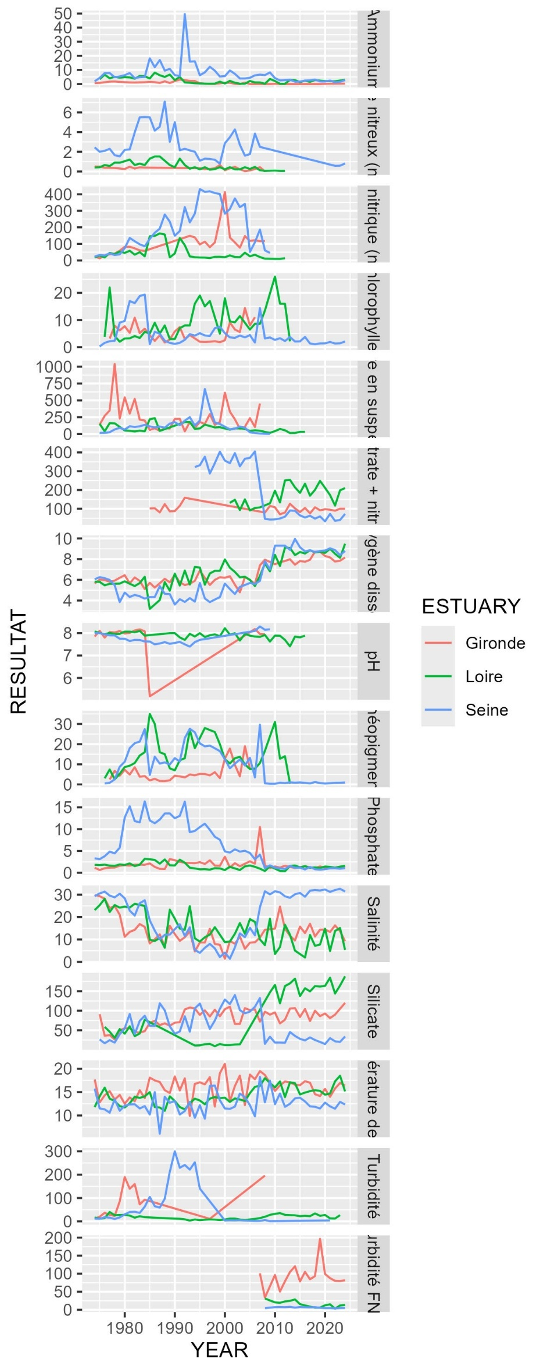

#### PCA

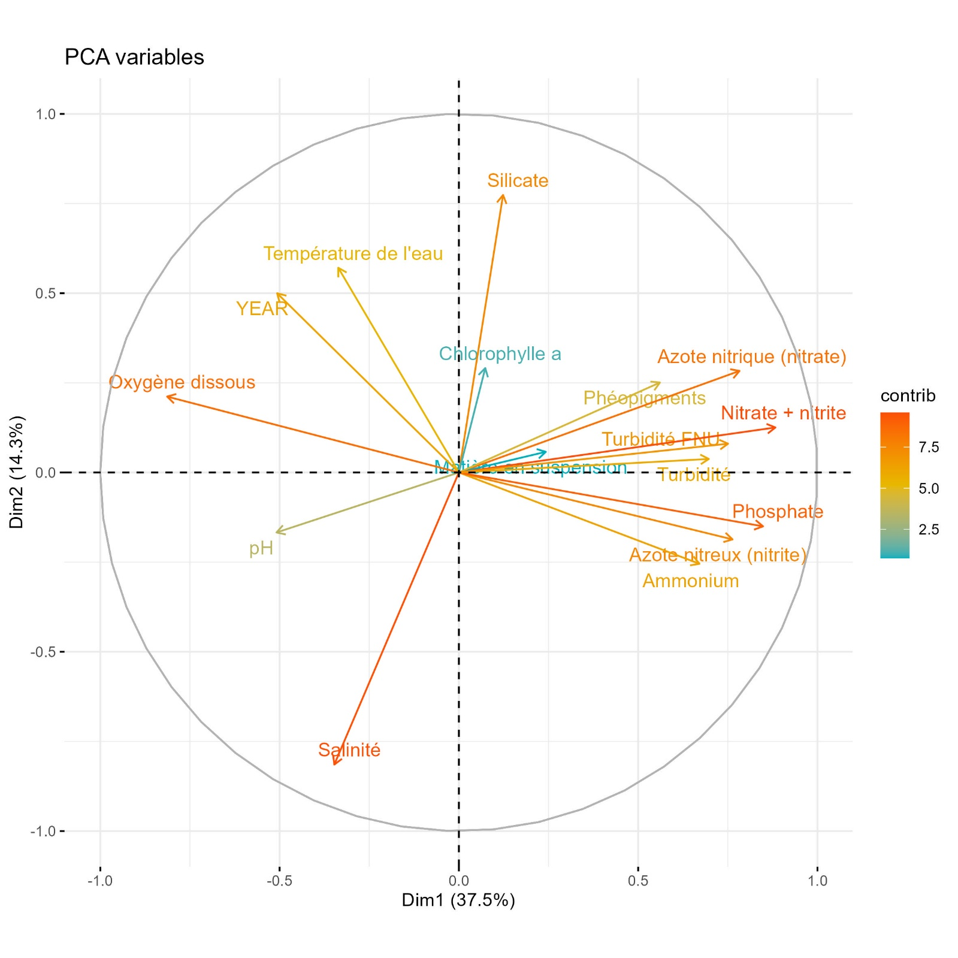

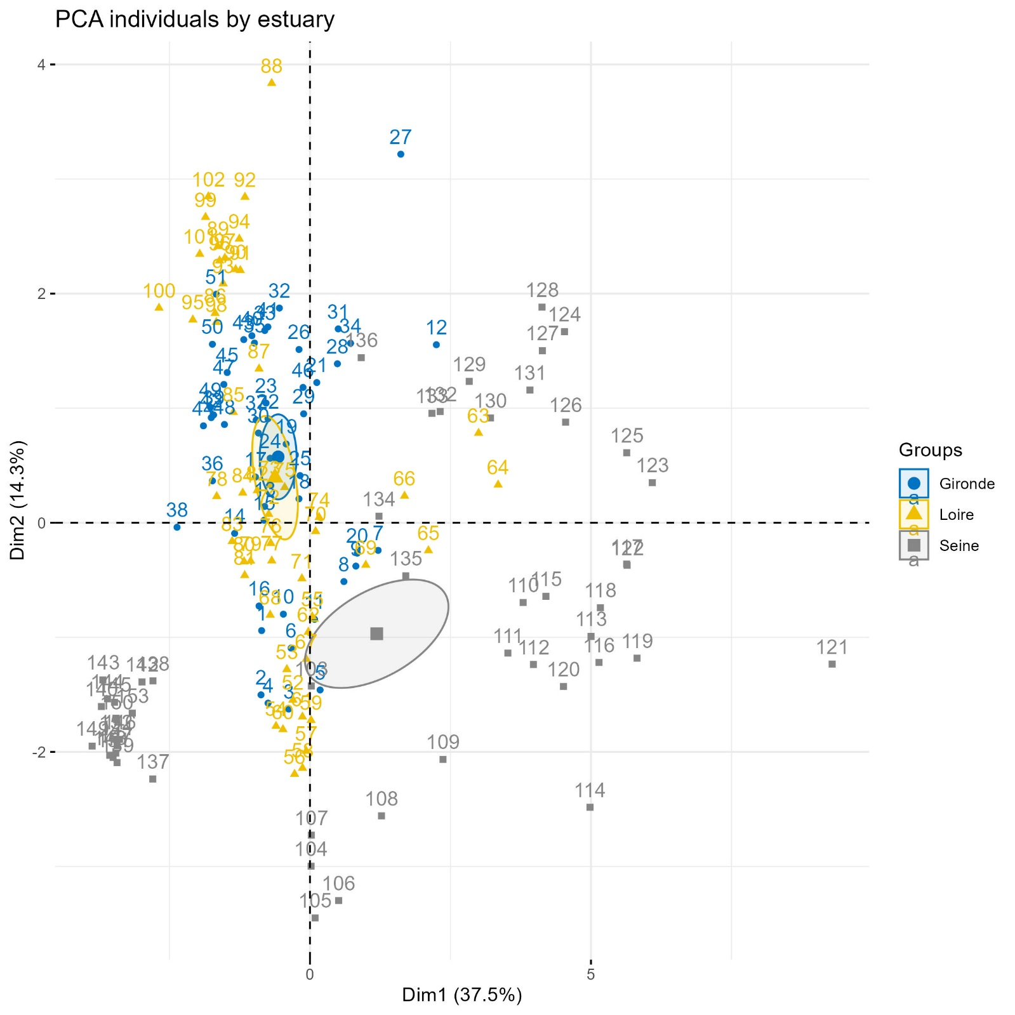

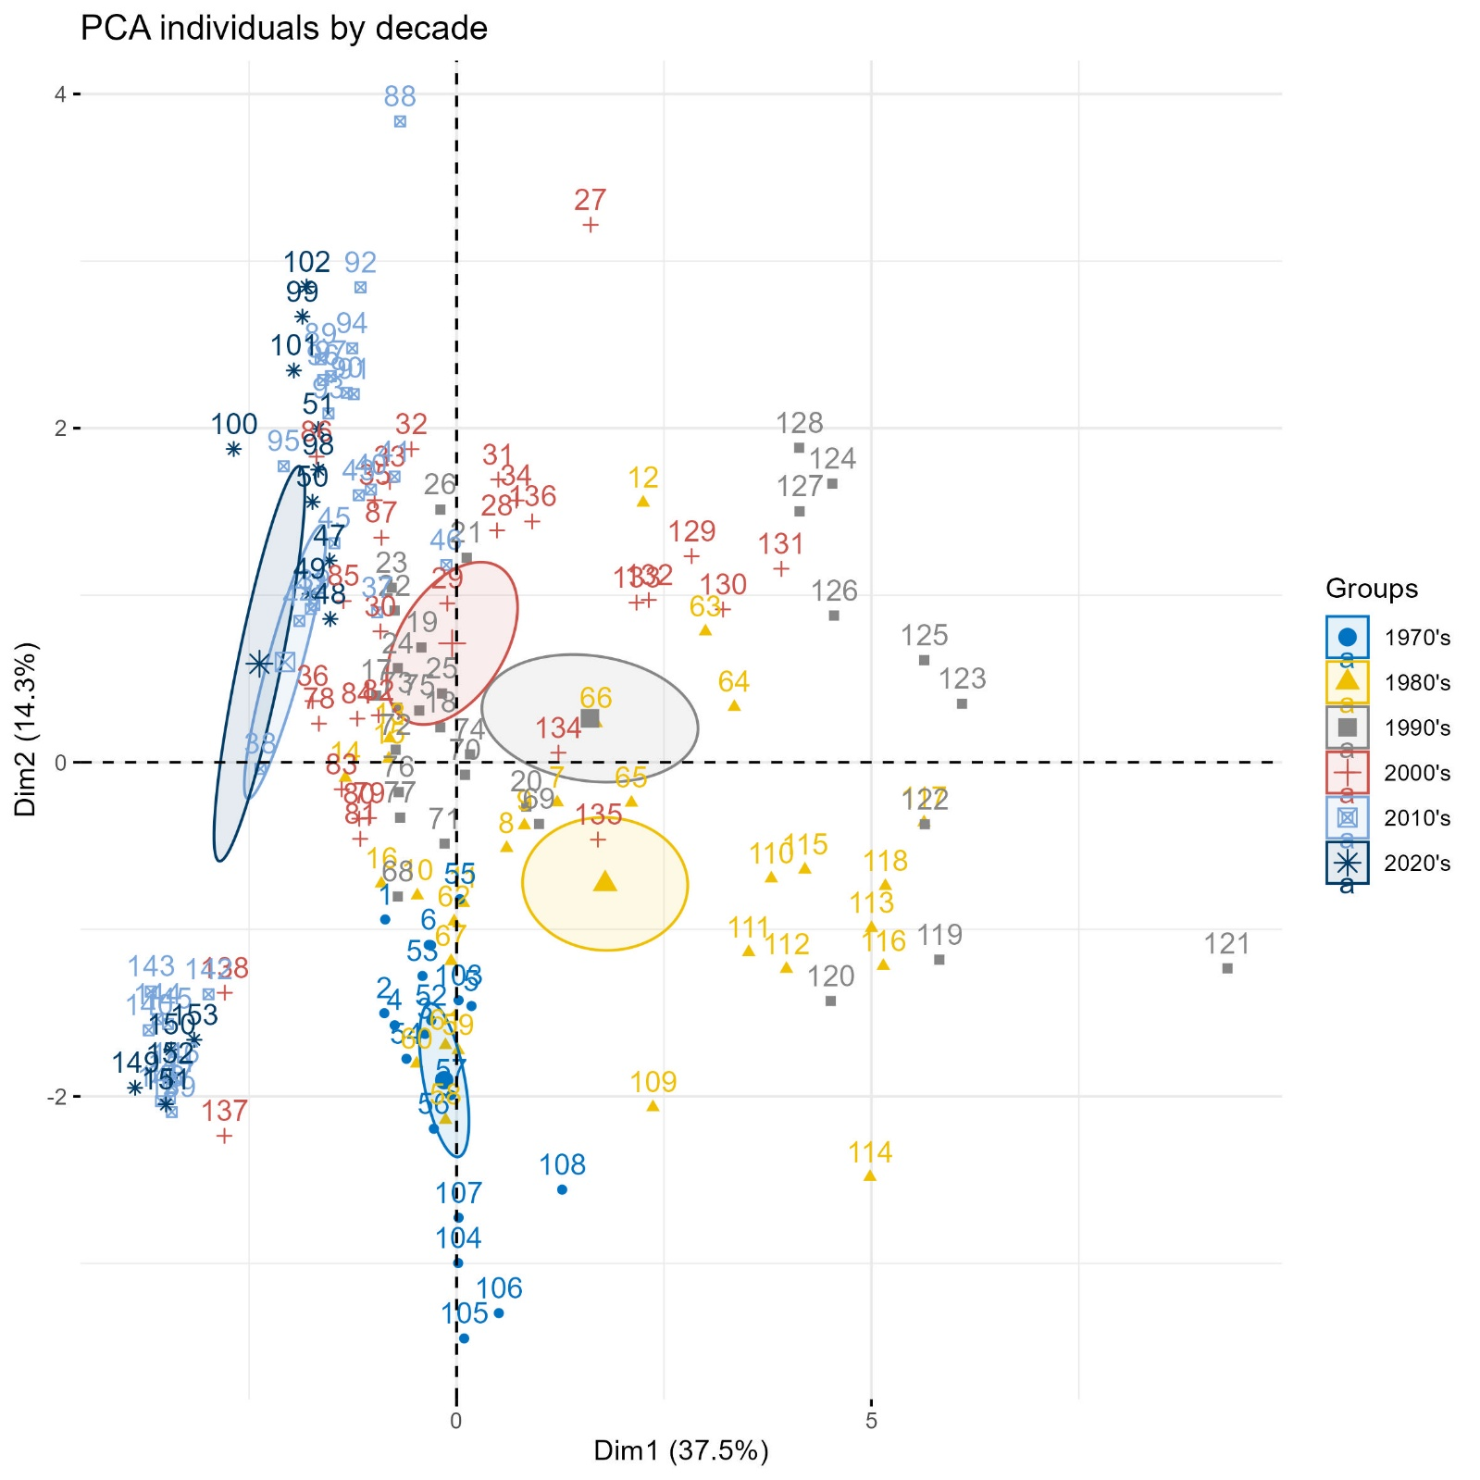

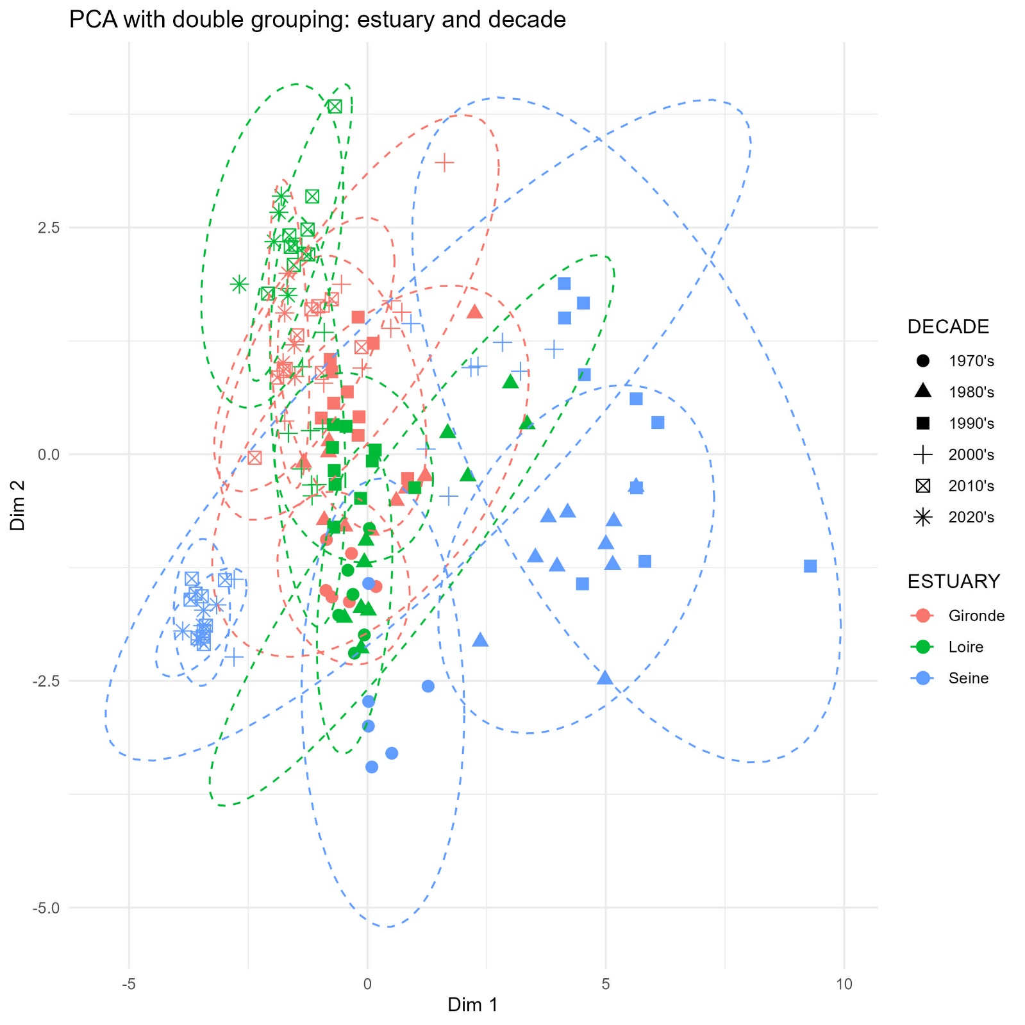

## Results

### Contamination

#### Metals

|  |  |
| --- | --- |
|  |  |
| Figure 2 – Time series of metal contamination in the Gironde, Loire and Seine estuaries from 1979 to 2024. Arrows indicate trends over the most recent 15-year period (Spearman’s rank correlation test). Dashed horizontal lines represent current sanitary thresholds, where applicable. | Figure 3 – Long term evolution of metal contamination in the Gironde, Loire and Seine estuaries, expressed as percentage deviation from current sanitary thresholds, where applicable. Comparisons are made between the periods 1979–1983 (First period) and 2020–2024 (Last period). Arrows indicate long-term trends (Kruskal-Wallis rank sum test). |

Time series data on metal contamination from 1979 to 2024 indicate that, across all estuaries, mercury consistently remains the least detected contaminant during the 2020-2024 period, with a median concentration of 0.025 µg/gww. This is followed by cadmium (0.230 µg/gww), lead (0.249 µg/gww), and copper (2.069 µg/gww).

Contaminant levels for each metal remain below the established sanitary thresholds (OSPAR, 2023a) across all estuaries, with the exception of cadmium in the Gironde estuary, where concentrations exceed the threshold by a factor 2.5. Overall, the Gironde estuary exhibits the highest metal contamination, while the Seine estuary is the least contaminated.

Historical data reveal that the Gironde estuary has consistently been more contaminated than the other, particularly with cadmium and copper. Between 1979 and 1983, cadmium and copper concentrations in the Gironde were approximately 28-fold and 3-fold higher, respectively, compared to the Loire estuary, which exhibited the lowest levels during that period. A long-term comparison between the first and last five years of monitoring (1979–1983 vs. 2020–2024) shows a significant decline in cadmium concentrations across all estuaries. In the Gironde estuary, cadmium concentrations decreased from 7.7 to 2.4 µg/gww. However, current levels remain above the sanitary threshold (1 µg/gww) and those observed in the Loire (0.2 µg/gww) and Seine (0.3 µg/gww) estuaries. Over the past 15 years, cadmium concentrations have continued to decline across all estuaries, although the decrease is not statistically significant for the Seine and Gironde estuaries.

For copper, the concentration gap between the Gironde and the other estuaries has widened over time, driven by a significant long-term increase in the Gironde, while concentrations in the other estuaries have remained stable. Thought, recent trends indicate rising copper levels in all estuaries, with a significant increase observed in the Loire.

No significant long-term or recent trends were detected for mercury concentrations in any estuary.

Lead concentrations show a significant long-term and recent decline in the Loire estuary. No significant trends were identified in the other estuaries, however, results indicate a decreasing trend in the Seine estuary and an increasing trend in the Gironde estuary.

#### Organochlorine pesticides

|  |  |
| --- | --- |
| Figure 4 – Time series of OC pesticides contamination in the Gironde, Loire and Seine estuaries from 1982 for lindane (gamma-HCH) and 1979 for DDT to 2023. Arrows indicate trends over the most recent 15-year period (Spearman’s rank correlation test). Dashed horizontal lines represent current ecotoxicological thresholds. | Figure 5 – Long term evolution of PCBi contamination in the Gironde, Loire and Seine estuaries, expressed as percentage deviation from current ecotoxicological thresholds. Comparisons are made between the periods 1982–1986 (First period for lindane) or 1979-1983 (First period for DDT) and 2019–2023 (Last period). Arrows indicate long-term trends (Kruskal-Wallis rank sum test). |

Long-term trends show a significant decrease in concentrations of both OC pesticides across all estuaries.

Although γ-HCH exceeded its ecotoxicological threshold during the initial years of monitoring, its concentrations have declined markedly and it has not been detected in approximately the past ten years.

Recent trends for the sum of DDT-related compounds indicate a significant decrease in the Loire and Seine estuaries, while non-significant increase was observed in the Gironde estuary. Currently, DDT concentrations are below the ecotoxicological threshold in all estuaries, at less than 2% of the threshold value.

#### Polycyclic aromatic hydrocarbon (PAH)

|  |  |
| --- | --- |
| Figure 6 – Time series of PAH compounds contamination in the Gironde, Loire and Seine estuaries from 1994 to 2024. Arrows indicate trends over the most recent 15-year period (Spearman’s rank correlation test). Dashed horizontal lines represent current ecotoxicological thresholds. | Figure 7 – Long term evolution of PAH compounds contamination in the Gironde, Loire and Seine estuaries, expressed as percentage deviation from current ecotoxicological thresholds. Comparisons are made between the periods 1994–1998 (First period) and 2020–2024 (Last period). Arrows indicate long-term trends (Kruskal-Wallis rank sum test). |

Time-series data show that contamination levels of all PAH compounds remain below their respective OSPAR ecotoxicological thresholds across all estuaries. Among them, the Seine estuary exhibits the highest PAH concentrations, while the Loire and Gironde estuaries show similar and comparatively lower levels.

Most long-term and recent trends indicate decreasing concentrations across estuaries, whether statistically significant or not. An exception is observed for benzo(ghi)perylene in the Gironde estuary, where a slight increase is recorded. The long term increase corresponds to a +2% deviation from the threshold and is statistically significant in the recent trend (Spearman’s ρ = +0.6% of the threshold value per year, p.value = 0.002).

#### PCB indicators

|  |  |
| --- | --- |
| Figure 8 – Time series of PCBi contamination in the Gironde, Loire and Seine estuaries from 1988 to 2024. Arrows indicate trends over the most recent 15-year period (Spearman’s rank correlation test). Dashed horizontal lines represent current ecotoxicological thresholds. | Figure 9 – Long term evolution of PCBi contamination in the Gironde, Loire and Seine estuaries, expressed as percentage deviation from current ecotoxicological thresholds. Comparisons are made between the periods 1988–1992 (First period) and 2020–2024 (Last period). Arrows indicate long-term trends (Kruskal-Wallis rank sum test). |

Time series data on PCB indicators (PCBi) contamination from 1988 to 2024 indicate a generally significant lon-term decline in concentrations for all congeners across the three estuaries. In contrast, recent trends over the past 15 years show mostly non-significant changes in contamination levels, with the exception of CB 52 and CB 118 in the Seine estuary, for which significant decreasing trends were observed.

The Seine estuary consistently exhibits higher levels of contamination compared to the other estuaries, with congener-specific differences ranging from a 2.5-fold increase for CB153 to a 9-fold increase for CB118. The Gironde and the Loire estuaries display comparable PCBi contamination levels, except for CB 153 and CB180, for which concentrations in the Gironde approach those observed in the Seine.

In 2024, the most recent monitoring year, all estuaries reported concentrations below the OSPAR legislative thresholds for PCB congeners with both the lowest (CB 28,CB 152) and highest (CB 153, CB 180) hydrophobicity levels (Hawker and Connell, 1988). In contrast, congeners with intermediate hydrophobicity, associated with the highest bioaccumulation potential, exceed threshold in the Seine estuary (CB 101 and CB138), and in the case of CB 118 (a dioxine-like congeners with higher toxicity), in all estuaries.

#### Dioxins and dioxin-like compounds

|  |  |
| --- | --- |
| Figure 10 – Time series of summed dioxins and dioxin-like compound contamination in the Gironde, Loire and Seine estuaries from 2008 to 2024. Arrows indicate trends over the full monitoring period (Spearman’s rank correlation test). Dashed horizontal lines represent current sanitary thresholds. | Figure 11 – Percentage of deviation from current sanitary threshold in the Gironde, Loire and Seine estuaries over the full monitoring period for the sum of dioxins and dioxin-like compound contamination. |

The sum of dioxins and dioxin-like compound concentrations is highest in the Seine estuary, with levels approximately six times higher than those in the Loire estuary and sixteen times higher than those in the Gironde. The median concentration in the Seine estuary over the entire monitoring period is 2.7 times greater than the sanitary threshold established by the European Commission. Occasional peak values in both the Gironde and Loire estuaries also exceeded this threshold in specific years.

Over the full monitoring period, an increasing trend in dioxins and dioxin-like compound concentrations was observed in all estuaries, with a statistically significant increase in the Loire estuary. In the Seine estuary, however, the trend is more complex, showing a marked increase before 2015 followed by a modest decline thereafter.

#### Brominated flame retardant

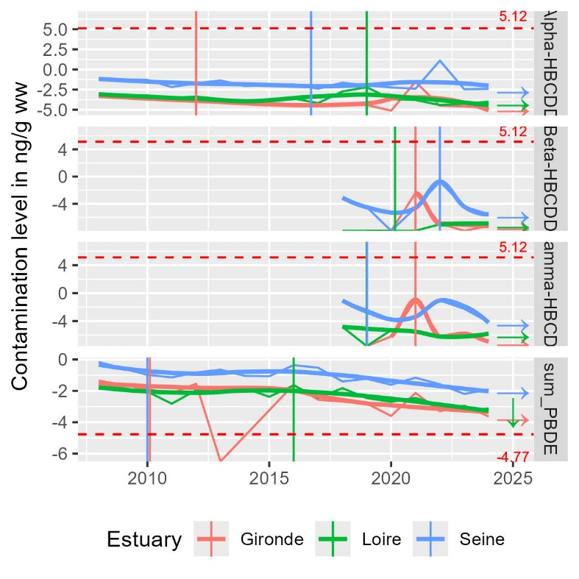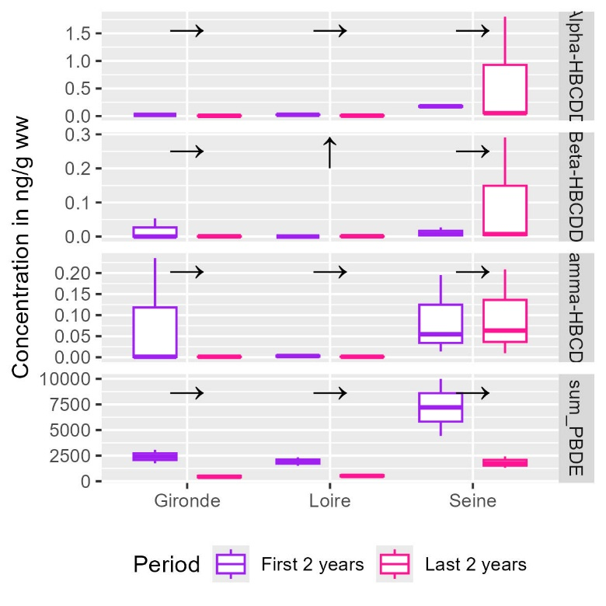

* Les retardateurs de flammes bromés ne sont suivis que depuis 2008 et les isomères beta et gamma de l’HBCDD ne sont suivis que depuis 2018. Les tendances à long terme portent donc sur des périodes de 2 ans
* Tous les isomères de HBCDD sont en dessous des normes environnementales et à des niveaux stables et très faibles (0 à 1.75 fois la norme) pour tous les estuaires. On n’observe pas de tendance d’évolution sauf une augmentation en Loire mais étant donné la courte période et les niveaux très faible on n’en tiendra pas compte
* Tous les estuaires sont bien au-dessus des normes environnementales pour les PBDE (4 et 5 fois la norme en Gironde et Loire respectivement, 17 fois la norme en Seine)

#### Perfluorinated compound: PFOS

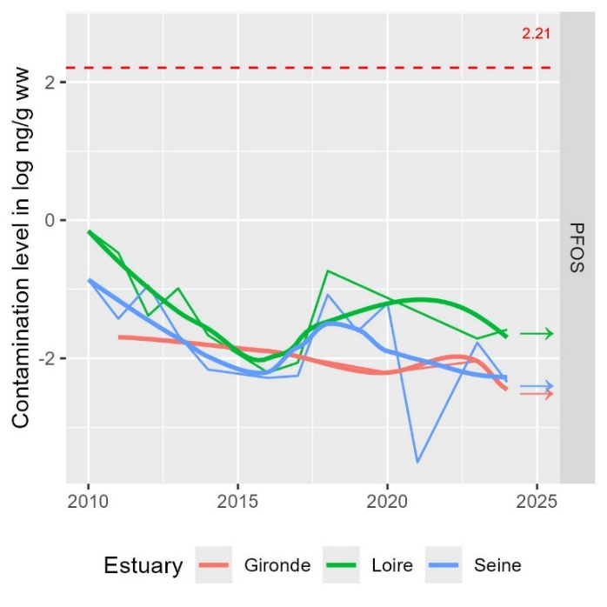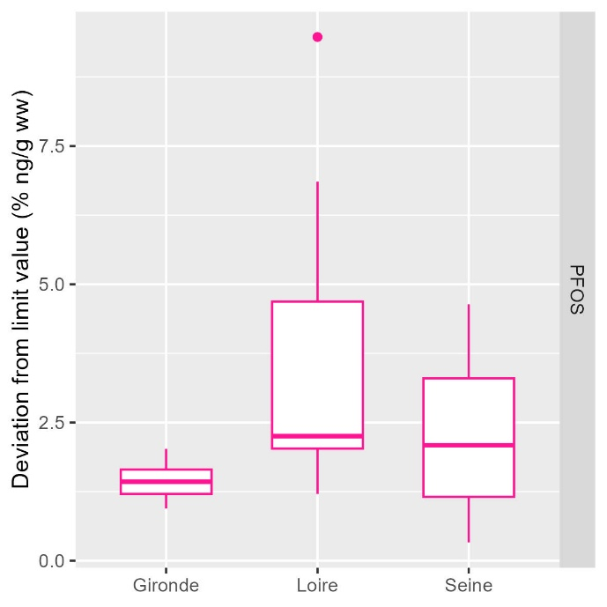

* Emergent, étude de la période récente seulement (depuis 2010)
* En dessous de la norme pour tous les estuaires (0.1 à 0.2 fois la norme)
* Pas de tendance d’évolution récente

#### Tributyltin cation

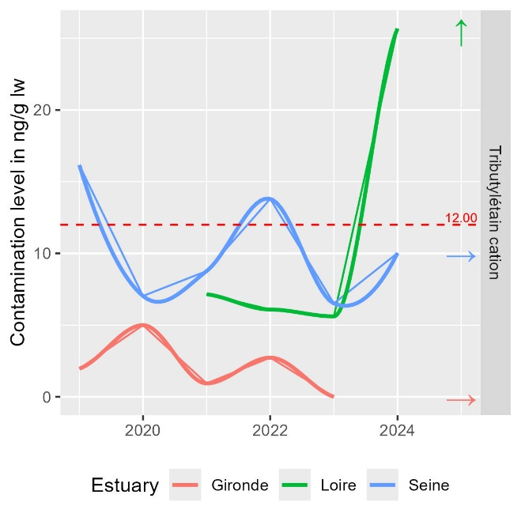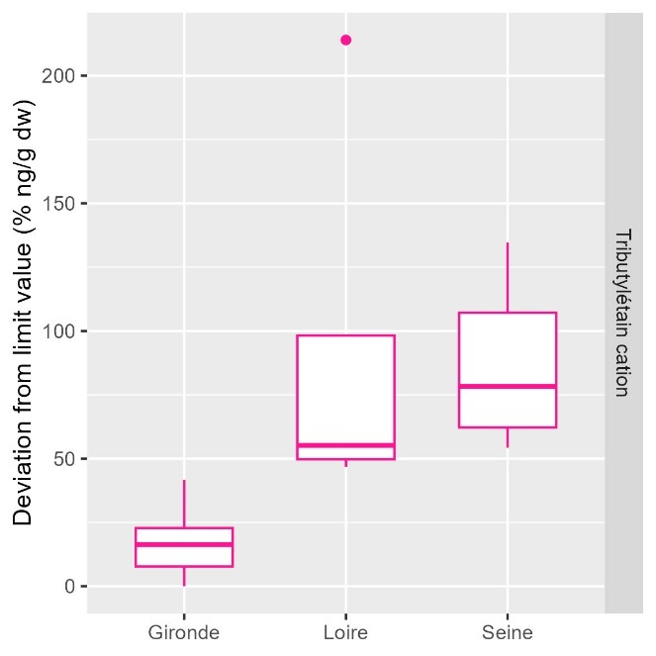

* Emergent, étude de la période récente seulement
* Un dépassement en 2024 en Loire avec une potentielle tendance à l’augmentation avec des dernières valeurs autour de 2.25 fois la norme (seulement 2 années de mesure)
* Des dépassements ponctuels en Seine avec des valeurs autour de 0.5 à 1.25 fois la norme
* Des niveaux faibles (0-0.5 fois la norme) et pas de tendance d’évolution en Gironde

### Benthic macrofauna

#### Campaign

|  |  |
| --- | --- |
|  |  |
|  | |

#### Species richness

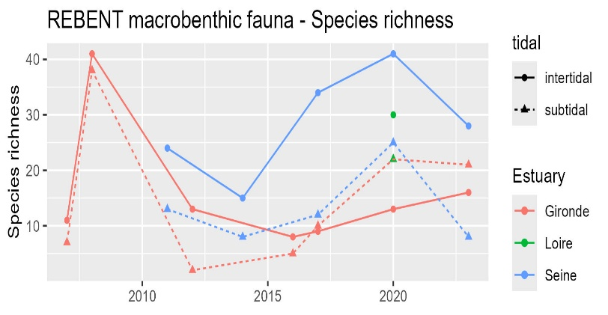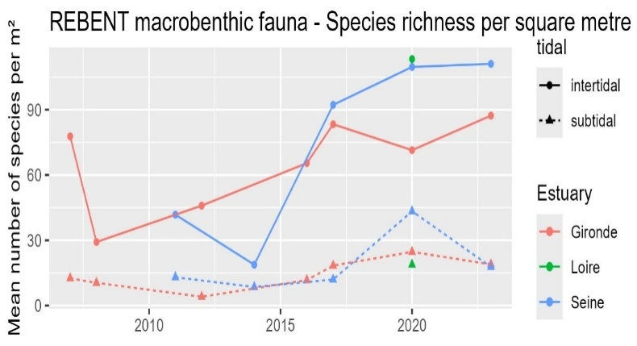

* Higher species richness in intertidal compared to subtidal areas
* Compared to the Gironde estuary, the Seine estuary exert higher species richness levels in both area since 2016
* The Loire estuary exert the lowest species richness in subtidal areas but the highest species richness in intertidal areas
* Species richness is increasing since 2007 in the Gironde and the Seine estuaries.

#### Taxonomic composition

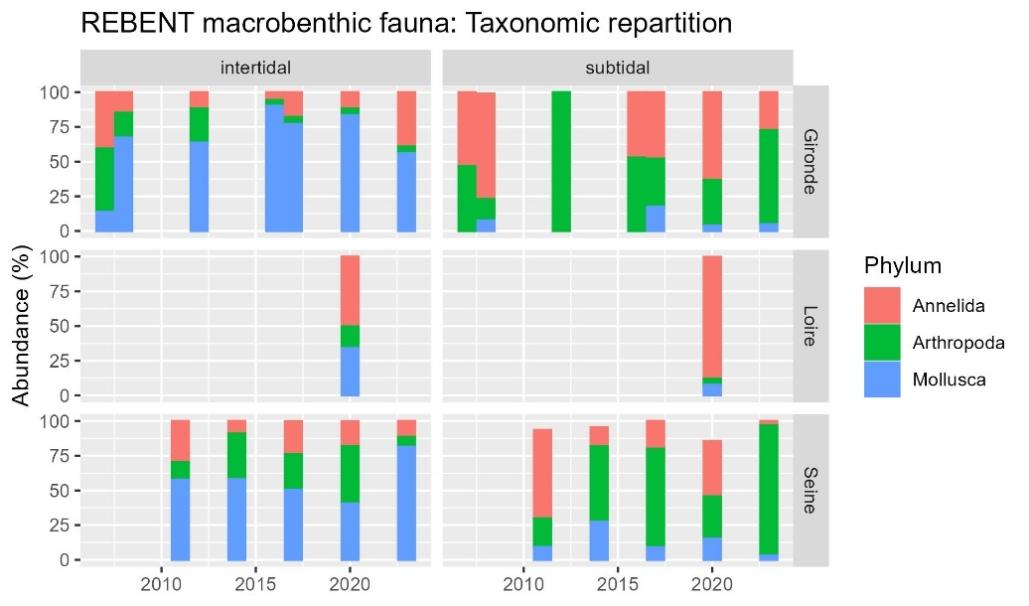

* Intertidal: highest abundance for molluscs for Gironde and Seine, annelids in Loire (Cordemay amphipodes ++ since 2020)
* Subtidal: highest abundance of arthropods, than annelids, for Gironde and Seine, annelids in Loire

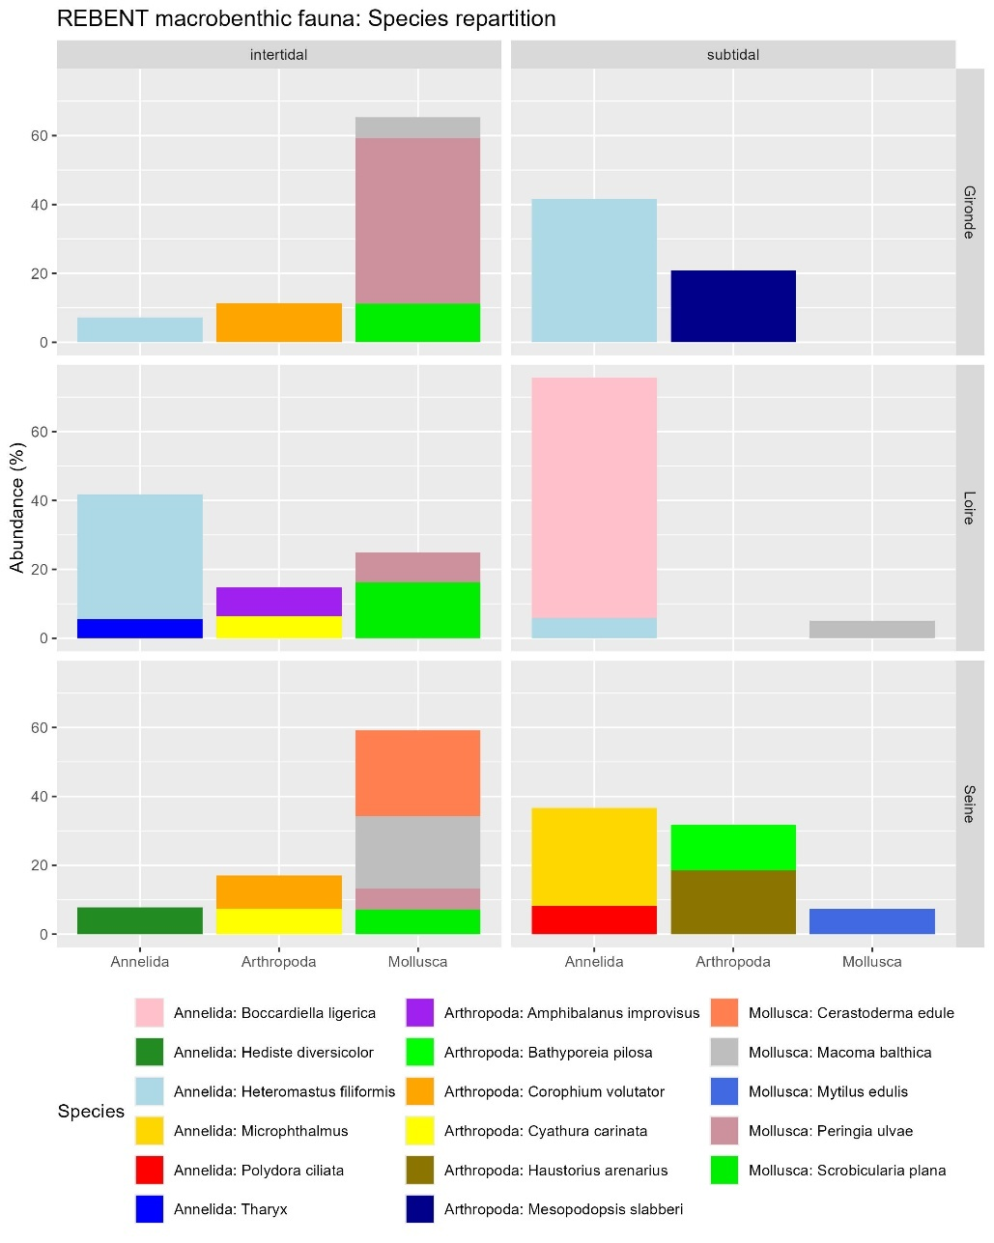

#### Abundance / Density

|  |  |
| --- | --- |
|  | * Much higher in intertidal areas than in subtidal areas * 3 fold higher in Loire intertidal areas than the highest densities in other estuaries and areas. * Seems to increase in both areas of the Seine and the Gironde estuary since 2007 |

#### Shannon index: biodiversity heterogenicity

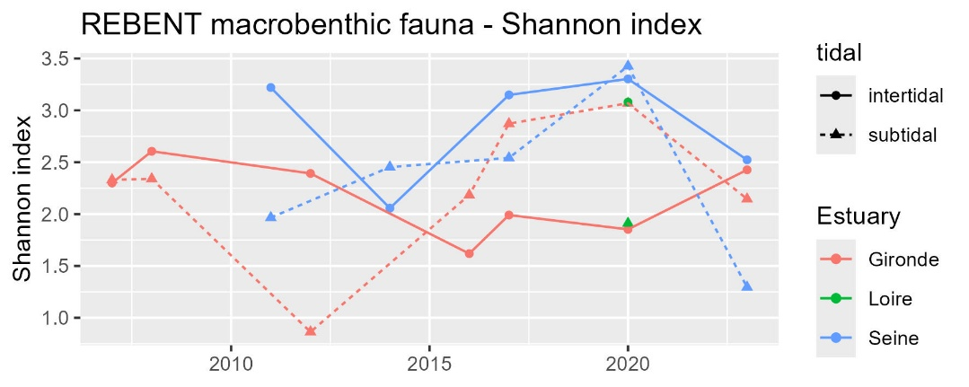

#### AMBI index: disturbances sensitivity (0 good – 7 bad)

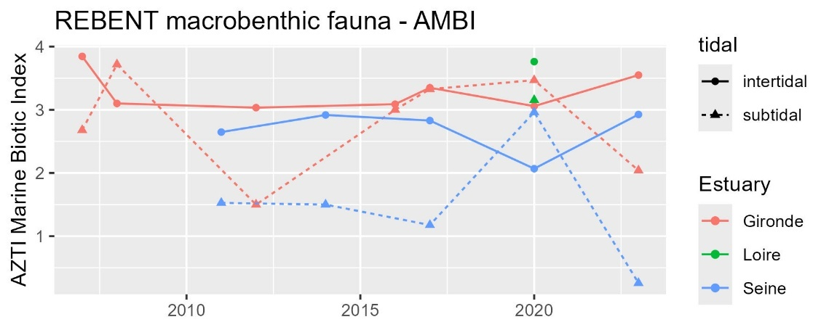

#### BEQI-Fr index: general quality

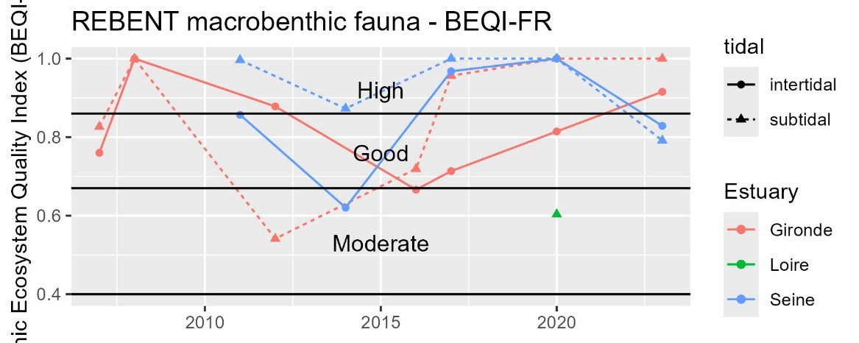

### Physico-chemical parameters

#### Primary production: pheopigment / chlorophyl a

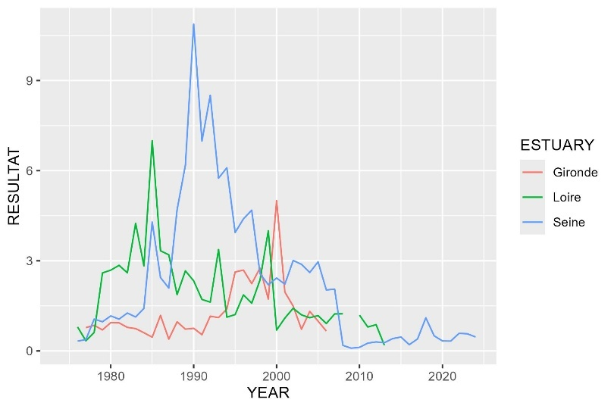

#### Nitrification cycle: Ammonium / nitrate+nitrite

|  |  |
| --- | --- |
|  | La somme calculée en Loire semble plus forte que celle mesurée dans Quadrige   * On garde quand même ? |
|  | * Reconstruction de la somme nitrate+nitrite à partir de la valeur max de « Nitrate + nitrite » ou « sumNO2NO3 » * Indicateur = Ammonium / (N02+NO3) * Ratio < 0.1 🡪 bonne nitrification * Ratio entre 0.1 et 1 🡪 conditions intermédiaires, dysfonctionnement saisonnier possible du cycle avec accumulation d’ammonium pouvant indiquer hypoxie, pollution organique, altération microbiologique |

## Supplementary

### Benthic habitats definition for BEQI-FR definition of reference states

#### EUNIS habitats characteristics

|  |  |  |  |  |  |  |  |  |
| --- | --- | --- | --- | --- | --- | --- | --- | --- |
| INTERTIDAL AREAS | | | | | | | | |
| EUNIS 2012 | Label | Taxon | Species density | Grain size | <63 µm | Organic matter | Salinity | Exposition (hydro) |
| MoSa A2.22 | Barren or amphipod dominated mobile sand shores. | Major: Amphipods  Potential : mobile crustaceans | Low | Medium size sand | No fine particules | Very low | High (mouth) | High |
| FiSa A2.23 | Polychaete or amphipod-dominated fine sand shores | Major: amphipods (haustorids maily Bathyporeia spp.) OR polychaetes (Eteone sp., Capitellidae) | High (+ highest diversity) | Fine sand | No fine particules | Very low | High | Moderate |
| MuSa A2.24 | Polychaete or bivalve-dominated muddy sand shores. | Major: Polychaetes (tolerant e.g. Spionidae or indicator of pollution Capitellidae)  OR bivalves (tellinids and semelids) Others: venerid bivalves + amphipods | Relatively high | Fine sand  (100 and 300 μm)  Few gravels | 3-33% | 1-3% | High but variable (mouth) |  |
| MEst A2.31 | Polychaete/bivalves-dominated mid estuarine mud shores. | Major sensitive species:  - Polychaetes (Nephtys hombergii, Hediste diversicolor, Heteromastus filiformis, Pygospio elegans and Eteone sp.. Peringia ulvae)  - Bivalves (Limecola balthica, Scrobicularia plana > Cerastoderma edule, Ruditapes spp., Abra tenuis) |  | Fine sandy-mud (20 and 150 μm) Few gravels | 15-75 % | 2-7% | Median subjected to freshwater influence |  |
| UEst A2.32 (upper MEst) | Polychaete/oligochaete-dominated upper estuarine mud shores. | - Polychetes (Nereids Allita succinea, Spionids Boccardiella sp.) and oligochetes (AMBI group III)  - also crustaceans (Corophium volutator, Cyathura carinata) - Disparition of sensitive species (e.g. S. plana)  - Apparition of invasive freshwater species (Corbicula fluminea)  - No other bivalves | Low | Muddy (40% of very fine sand 20 and 60 μm)  No gravel | 75 and 100 % | 4-7% | Low (subjected to strong freshwater influence) |  |

|  |  |  |  |  |  |  |  |  |
| --- | --- | --- | --- | --- | --- | --- | --- | --- |
| SUBTIDAL AREAS | | | | | | | | |
| EUNIS 2012 | Label | Taxon | Species density/diversity | Grain size | <63 µm | Organic matter | Salinity | Exposition (hydro) |
| SMuVS A5.32 | Sublittoral mud in variable salinity  (intertidal habitas of UEst) | * Oligochaetes * Polychaetes: Capitellidae (Heteromastus sp.), Spionidae, Nereidae, Phyllodocidae Some crustaceans: Corophium volutator, Cyathura carinata * Some molluscs : Scrobicularia plana, Limecola balthica (North Gironde estuary species) | Medium | Fine sand (20 and 200 μm)  Mud | 20-100% | 3-7% | variable |  |
| SSaVS A5.22 | Sublittoral sand in variable salinity | Sensitive species (AMBI group I) Amphipods: Eurydice spp., Bathyporeia spp. (highly mobile)  Polychaetes: Capitellidar, Ophelidae, Nephtyidae  Mysids shrimps : Gastrosaccus spp. | Low | Medium size sand (250-400 µm)  No gravel | <1-3 % | < 1 % | variable | Moderate |
| IMuSa A5.24 | Infralittoral muddy-sand (around MEst) | (AMBI group II and III)  Polychaetes: Magelona mirabilis, Spiophanes bombyx et Chaetozone setosa  Bivalves: Tellina fabula et Chamelea gallina | High | Muddy-sand  (70-200µm) | 5-20 % | 2-7 % | High | Marine bay |

#### Sediment grain size proportions

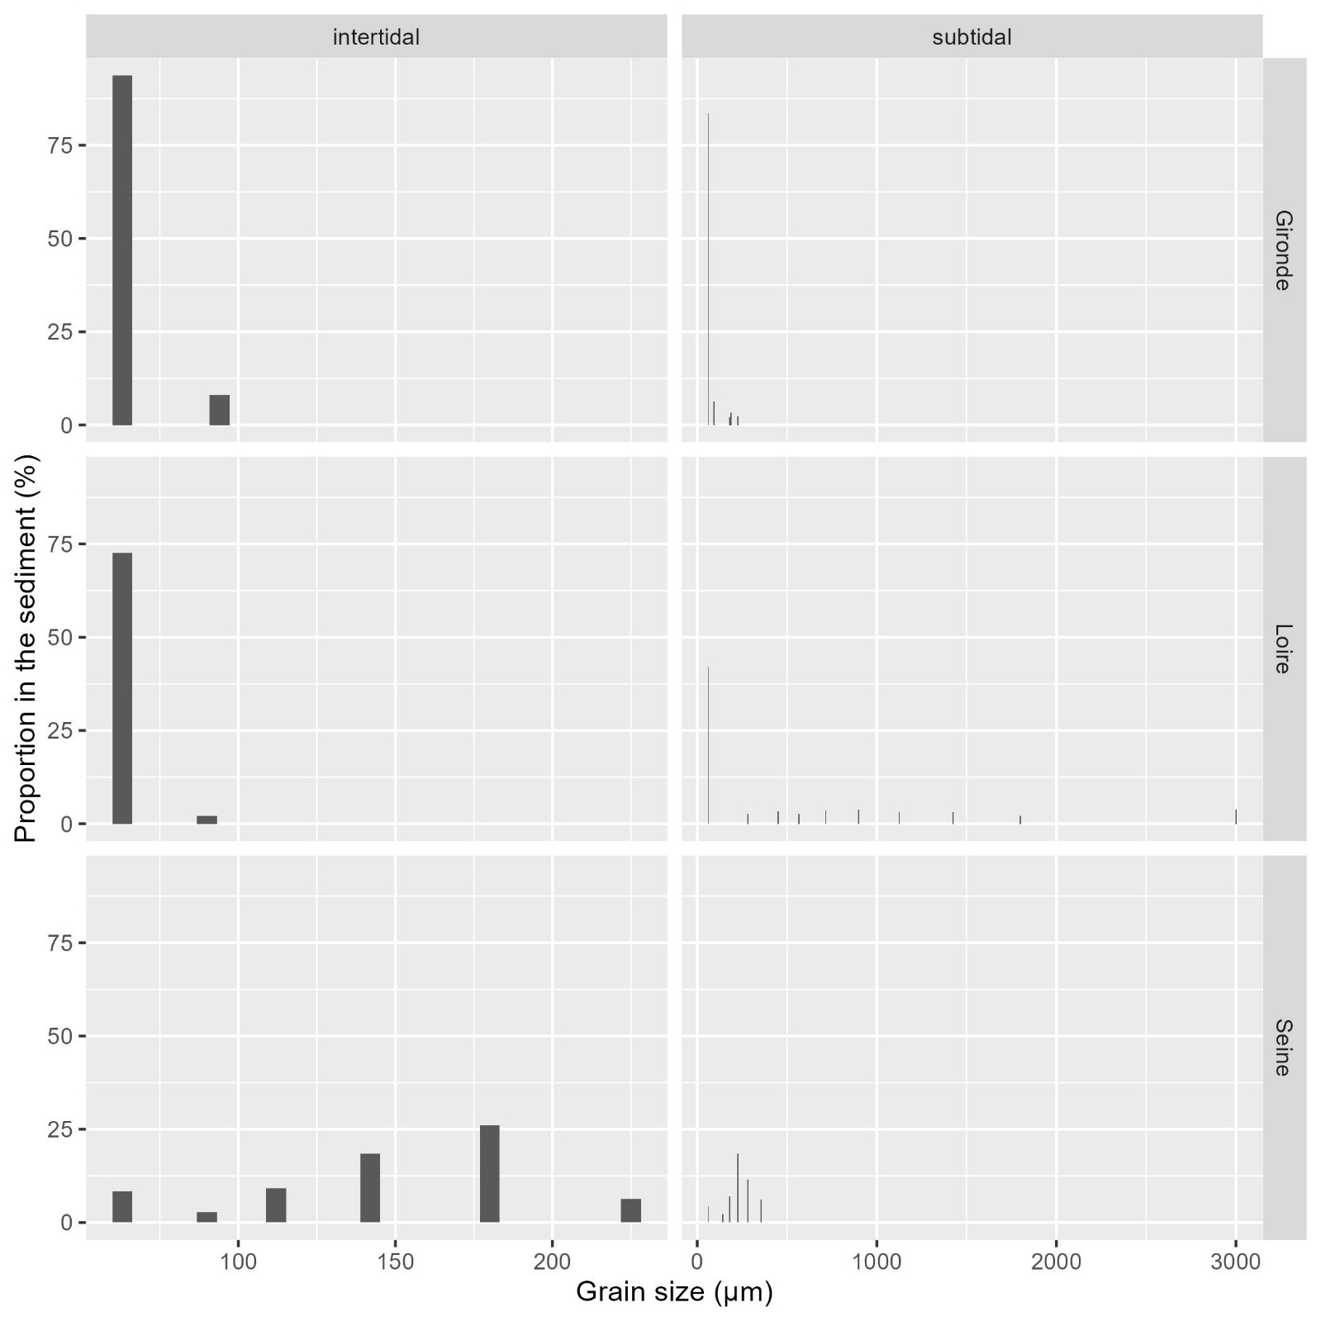

#### Benthic species composition

|  |  |  |  |  |  |  |
| --- | --- | --- | --- | --- | --- | --- |
| ESTUARY | tidal | phylum | class | order | species | abundance_prop |
| Gironde | intertidal | Arthropoda | Crustacea | Multicrustacea | Corophium volutator | 11,38123 |
| Gironde | intertidal | Mollusca | Bivalvia | Autobranchia | Scrobicularia plana | 11,25635 |
| Gironde | intertidal | Mollusca | Gastropoda | Caenogastropoda | Peringia ulvae | 48,12255 |
| Gironde | subtidal | Annelida | Polychaeta | Sedentaria | Heteromastus filiformis | 41,60935 |
| Gironde | subtidal | Arthropoda | Crustacea | Multicrustacea | Mesopodopsis slabberi | 20,83906 |
| Loire | intertidal | Annelida | Polychaeta | Sedentaria | Heteromastus filiformis | 36,23616 |
| Loire | intertidal | Mollusca | Bivalvia | Autobranchia | Scrobicularia plana | 16,21156 |
| Loire | subtidal | Annelida | Polychaeta | Sedentaria | Boccardiella ligerica | 69,68577 |
| Seine | intertidal | Mollusca | Bivalvia | Autobranchia | Cerastoderma edule | 24,90826 |
| Seine | intertidal | Mollusca | Bivalvia | Autobranchia | Macoma balthica | 20,91743 |
| Seine | subtidal | Annelida | Polychaeta | Errantia | Microphthalmus | 28,30508 |
| Seine | subtidal | Arthropoda | Crustacea | Multicrustacea | Haustorius arenarius | 18,47458 |
| Seine | subtidal | Arthropoda | Crustacea | Multicrustacea | Bathyporeia pilosa | 13,38983 |

## References

Blanchet, H. et al. (2025) Méthodologie pour la surveillance et l’évaluation du paramètre « Macro-invertébrés benthiques » dans les masses d’eau de transition estuariennes de la façade Manche- Atlantique –. Available at: https://archimer.ifremer.fr/doc/00887/99923/118418.pdf (Accessed: 9 July 2025).

Borja, A., Franco, J. and Pérez, V. (2000) ‘A Marine Biotic Index to Establish the Ecological Quality of Soft-Bottom Benthos Within European Estuarine and Coastal Environments’, Marine Pollution Bulletin, 40(12), pp. 1100–1114. Available at: https://doi.org/10.1016/S0025-326X(00)00061-8.

Borja, A. and Muxika, I. (2005) ‘Guidelines for the use of AMBI (AZTI’s Marine Biotic Index) in the assessment of the benthic ecological quality’, Marine Pollution Bulletin, 50(7), pp. 787–789. Available at: https://doi.org/10.1016/j.marpolbul.2005.04.040.

European Commission (2013) DIRECTIVE 2013/39/EU OF THE EUROPEAN PARLIAMENT AND OF THE COUNCIL of 12 August 2013 amending Directives 2000/60/EC and 2008/105/EC as regards priority substances in the field of water policy. Annex II ENVIRONMENTAL QUALITY STANDARDS FOR PRIORITY SUBSTANCES AND CERTAIN OTHER POLLUTANTS. Available at: https://eur-lex.europa.eu/eli/dir/2013/39/oj/eng (Accessed: 2 July 2025).

Fouet, M. et al. (2018) Sélection d’un indicateur DCE « faune benthique invertébrée » adapté aux estuaires. DOC00085633. Agence française pour la biodiversité - AFB, Université de Bordeaux Irstea, p. 77. Available at: https://professionnels.ofb.fr/fr/doc/selection-dun-indicateur-dce-faune-benthique-invertebree-adapte-aux-estuaires (Accessed: 8 July 2025).

Fouet, M., Blanchet, H. and Lepage, M. (2020) Intercalibration of biological elements for French transitional water bodies: benthic invertebrates. Water framework directive.

Hawker, D.W. and Connell, D.W. (1988) ‘Octanol-water partition coefficients of polychlorinated biphenyl congeners’, Environmental Science & Technology, 22(4), pp. 382–387. Available at: https://doi.org/10.1021/es00169a004.

Ifremer (2021) 20 ans de suivi de la contamination chimique des eaux côtières méditerranéennes : Résultats et perspectives. Available at: https://archimer.ifremer.fr/doc/00673/78554/80744.pdf (Accessed: 2 July 2025).

Ifremer (2024) Qualité du Milieu Marin Littoral. Bulletin de la surveillance 2023. Départements de la Gironde, des Landes et des Pyrénées atlantiques. Laboratoire Environnement Ressources d’Arcachon/Anglet. Ref. ODE/COAST/LERAR/24.013. Ifremer, p. 194. Available at: https://archimer.ifremer.fr/doc/00924/103575/ (Accessed: 3 July 2025).

Ineris (2022) Bilan annuel des travaux sur la thématique « substances dangereuses » dans le cadre de la convention OSPAR pour la protection et la préservation de l’Atlantique Nord-Est et ses ressources. Available at: https://www.ineris.fr/sites/ineris.fr/files/contribution/Documents/Suivi%20des%20travaux%20OSPAR%20%7B6%7Dsubstances%20dangereuses%7B6%7D%20v1.pdf.

Légifrance (2023) Article 3 de l’arrêté du 9 octobre 2023 modifiant l’arrêté du 25 janvier 2010 relatif aux méthodes et critères d’évaluation de l’état écologique, de l’état chimique et du potentiel écologique des eaux de surface pris en application des article R. 212-10, R. 212-11 et R. 212-18 du code de l’environnement. Available at: https://www.legifrance.gouv.fr/jorf/id/JORFTEXT000048347187 (Accessed: 2 July 2025).

legifrance.gouv (2023) Arrêté du 9 octobre 2023 modifiant l’arrêté du 25 janvier 2010 relatif aux méthodes et critères d’évaluation de l’état écologique, de l’état chimique et du potentiel écologique des eaux de surface pris en application des article R. 212-10, R. 212-11 et R. 212-18 du code de l’environnement - Légifrance. Available at: https://www.legifrance.gouv.fr/jorf/id/JORFSCTA000048347211?utm_source=chatgpt.com (Accessed: 17 May 2025).

van Loon, W.M.G.M. et al. (2015) ‘Application of the Benthic Ecosystem Quality Index 2 to benthos in Dutch transitional and coastal waters’, Journal of Sea Research, 103, pp. 1–13. Available at: https://doi.org/10.1016/j.seares.2015.05.002.

OSPAR (2023a) Status and trend for heavy metals (Mercury, Cadmium and Lead) in fish, shellfish and sediment. Available at: https://oap.ospar.org/en/ospar-assessments/quality-status-reports/qsr-2023/indicator-assessments/heavy-metals-biota-sediment/ (Accessed: 3 July 2025).

OSPAR (2023b) Status and Trends in the Concentrations of Polycyclic Aromatic Hydrocarbons (PAHs) in Shellfish and Sediment. Available at: https://oap.ospar.org/en/ospar-assessments/quality-status-reports/qsr-2023/indicator-assessments/pah-shellfish-sediment/ (Accessed: 3 July 2025).

OSPAR (2023c) Status and Trends in the Levels of Imposex in Marine Gastropods (TBT in Shellfish). Available at: https://oap.ospar.org/en/ospar-assessments/quality-status-reports/qsr-2023/indicator-assessments/tbt-shellfish/ (Accessed: 3 July 2025).

OSPAR (2023d) Status and Trends of Polychlorinated Biphenyls (PCB) in Fish, Shellfish and Sediment. Available at: https://oap.ospar.org/en/ospar-assessments/quality-status-reports/qsr-2023/indicator-assessments/pcb-biota-sediment/ (Accessed: 3 July 2025).